Awareness Event

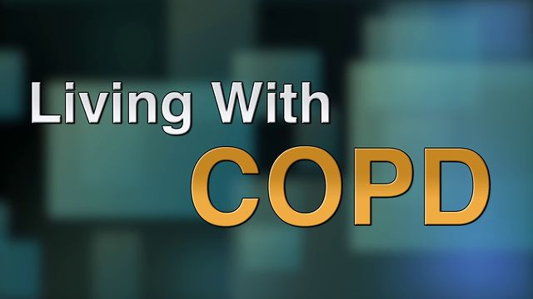
For people living with
chronic obstructive pulmonary disease, emphysema and chronic bronchitis

on Thursday 23rd March ‘17
2.00-4.00pm at the Trinity Centre, Wallington

NHS Sutton CCG and Sutton GP Practices are working in partnership to bring together local NHS services, social services, and voluntary groups and organisations to improve the health and well-being of local people living with COPD.

Trinity Centre, Holy Trinity Church, Maldon Rd, Wallington, SM6 8BL

All the activities are free, including blood pressure checks, medicine reviews, home safety checks, short talks and a wide range of information will be available to take away. Come and browse the information stands and meet the professionals delivering local services, including:

Breathe Easy

Community Pharmacists
- End of Life Care
- LiveWell Sutton
- Respiratory Specialist Nurses
- St Raphael’s Hospice
- Sutton Carers Centres
- Sutton Shop Mobility
- Sutton Uplift
- And more……………….

